The welfare state debate: who gets what and who pays for it?
Peter Whiteford
The appropriate level and structure of public spending is high on the policy agenda. A recent Grattan Institute report Budget pressures on Australian governments argues that Australian Federal and State governments potentially face a combined annual deficit of around 4 per cent of GDP by 2023, of which around 2.5 per cent of GDP would be at the Commonwealth government level. In a speech to the Institute of Public Affairs in early May this year, then Shadow Treasurer Joe Hockey said that ‘attacking spending’ and ‘looking for structural saves’ was increasingly urgent, and he referred back to a 2012 speech given at the Institute of Economic Affairs in London where he argued that ‘all developed countries are now facing the end of the era of universal entitlement. Addressing the ongoing fiscal crises will involve the winding back of universal access to payments and entitlements from the state.’
To a significant extent, the media reaction to these developments has been to call for cuts in public spending, particularly in ‘middle class welfare’. For example, Alan Kohler has argued that ‘Australia’s means testing regime is too loose. Too many people are getting too many benefits they don’t need because successive governments have tried to buy their votes. The health and welfare systems have been used as political tools, not safety nets. … As a result of poor means testing the health budget is out of control and ‘middle class welfare’ is blowing a huge hole in the budget.’ The Sydney Morning Herald has referred to the family assistance system as a ‘hotch potch ripe for an overhaul’, while former Labor Minister Gary Johns has argued in the Australian that too many are on the receiving end of middle-class welfare, but that for low income households ‘there is no dignity in not paying tax … where is the dignity in not making a contribution?’
The new Government’s plan for a substantially more generous system of paid parental leave has also been labeled by the Australian Financial Review as costly middle-class welfare. In a similar vein in the Australian earlier this year, Adam Creighton described the Family Tax Benefit Part B as a relic of the Howard era and ‘a superfluous $4.5bn-a-year cherry on a welfare cake that is choking economic growth and operating contrary to other government policies’, arguing that it is ‘surely it is not unfair to rein in a benefit that is paid to families in the top 10 per cent of the income distribution, with household incomes up to $175,600’.
The preference for cutting middle class welfare is in part motivated by the view that increasing taxes should not be used to bridge the budget gap. In an article in the Financial Review, Fleur Anderson suggested that ‘the middle class and the professions are staging a revolt as they find their growing share of the tax burden too hard to bear, after over a million people were made exempt from the tax system over the past 10 years’. The Financial Review and other commentators pointed to the latest ATO tax statistics for the 2010-11 financial year, which show that the top five per cent of income earners pay 34.1 per cent of net income tax, while the top 25 per cent of income earners pay just over two-thirds of net income tax. Correspondingly, about 45% of Australians pay no income tax at all, a figure very close to that used by Mitt Romney in the 2012 US Presidential election campaign when he argued that 47% of Americans pay no income tax and were therefore ‘moochers’. In a similar vein, Nicholas Eberstadt subsequently argued that the United States is now ‘on the verge of a symbolic threshold: the point at which more than half of all American households receive, and accept, transfer benefits from the government’ and suggesting that there was now a divide between the “takers” and the “makers”.
So should we bridge the budget gap by cutting spending, increasing taxes or some combination of the two approaches? It is worth noting the size of the gap as estimated by the Grattan Institute – in current terms 4 per cent of GDP is close to $60 billion and the Commonwealth share of this gap would be around $37 billion, and these amounts will be much larger by 2023.
In deciding which policy direction to follow it is also necessary to have a clear understanding of the distribution of welfare state spending – who gets what – and how spending is financed – who pays for it? Are higher income groups already overburdened with taxes or are they actually benefiting too much from profligate spending?
Fortunately for those interested in accurate answers to these questions, the Australian Bureau of Statistics has published studies of Government Benefits and Taxes and their impact on household incomes since the 1980s, with the most recent results being for 2009-10. These studies provide the most comprehensive accounting of government spending and taxation in Australia, as they not only include the impact of social security cash benefits and direct taxes, but they also take into account the effects of government spending on health care, education and community services, as well as the impact of indirect taxes, such as the GST. In contrast, the ATO statistics referred to above are useful, but they only identify who pays income taxes and do not include the GST or other indirect taxes, and nor do they tell us what benefits households receive from governments.
Chart 1 shows the distribution of all benefits and taxes across different quintiles of households in 2009-10 – quintiles comprise equal groups of exactly 20 per cent of all households, with their incomes adjusted for the number of people in the household and ranked from the poorest to the richest in terms of their private income.
Chart 1: Benefits received and taxes paid (2009-10 $pw) by quintiles of equivalised private income, Australia, 2009-10
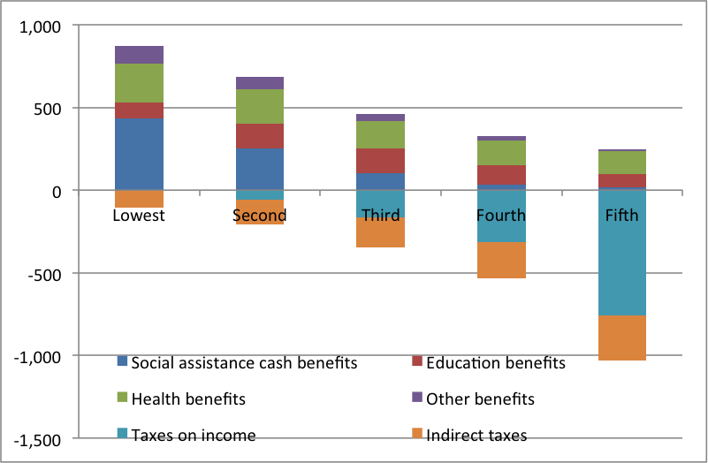
Source: Calculated from ABS, Government Benefits, Taxes and Household Income, Australia, 2009-10, Cat. No. 6537.0
For example, the poorest 20 per cent of households received about $435 per week in cash benefits and they received services worth about $446 per week (mainly public health care); they paid negligible amounts of income tax, but around $105 per week in indirect taxes. In contrast the richest 20 per cent of households received only $15 per week in cash benefits – or about one-thirtieth as much as the lowest income group – but they received $234 per week in government services, and they paid $756 per week in income taxes and $273 per week in indirect taxes.
In terms of government spending that benefits the richest households, health and education are far more important than social security. The richest quintile received only 1.7 per cent of social security benefits, but benefited from $83 per week in education benefits, or around 14 per cent of government education spending, and $140 per week in health benefits, or 15.5 per cent of health spending. Overall the non-cash benefits received by the richest were worth nearly 16 times as much as the cash benefits they received ($234 per week compared to $15 per week). This targeting of social security benefits to the poor is much greater in Australia than any other country. Even though Australia spends below the OECD average on social security benefits, the distribution of benefits is so progressive, and the level of taxes paid by the poor is so low, that Australia redistributes more to the poorest 20 per cent of the population than any other OECD country except Denmark (which spends about 80 per cent more than Australia).
It is also worth noting that of the cash benefits received by the richest 20 per cent of households, only $1 per week comes in the form of family payments, the usual suspect in the criticism of middle class welfare and the main target for reduced spending in the 2013-14 Budget. Most of the social security benefits received by the richest 20 per cent are age and disability pensions, Veterans’ Affairs pensions and unemployment benefits. This is not because the income-testing of these payments is lax, but because income tests in the social security system are based on the nuclear family, so this ‘leakage’ to high income households is mainly the result of aged or disabled people or the unemployed sharing a house with their parents or their children.
On the tax side, the richest quintile of households pays around 58 per cent of income taxes and 30 per cent of indirect taxes, although they have 45 per cent of private income. Direct and indirect taxes paid by the richest households amount to 46.5 per cent of all taxes paid; so while indirect taxes offset some of the progressivity of income taxes, the overall tax take is still progressive, as shown in Chart 2.
Chart 2: Direct and indirect taxes as per cent of income by quintiles of equivalised disposable income, Australia, 2009-10
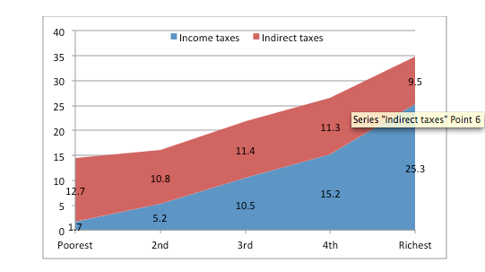
Source: Calculated from ABS, Government Benefits, Taxes and Household Income, Australia, 2009-10, Cat. No. 6537.0
Most importantly, of course these taxes pay for the benefits received by lower income households.
The overall scale of redistribution in Australia can be gauged from the fact that the richest 20 per cent of the population have private incomes that are more than 21 times higher than the private incomes of the poorest 20 per cent, but after benefits and services are received and taxes are paid that disparity is reduced to about 3 to 1 or by 86 per cent. In terms of improving the incomes of the poor, social security and government services are roughly equally important: the social security system increasing their share from 2 per cent of private income to nearly 7 per cent of gross income. Because the poorest income group pay a small fraction of one per cent of income taxes, their share of disposable income is increased to 8 per cent, with government services increasing this further to 11 per cent of final income. Although indirect taxes are regressive, taking 12.7 per cent of the income of the poorest households compared to 9.5 per cent of the income of the richest, they do not materially alter these disparities.
These ABS figures provide a snapshot of the distribution of benefits and taxes at a point in time, but in assessing proposals for reform it is worth revisiting the longer-term impact and objectives of the welfare state.
Overall, the Australian welfare state performs two main functions – redistribution between rich and poor (the Robin Hood function), but it also provides insurance and consumption smoothing (the ‘piggy‐bank’ function). In Australia we tend to focus on the idea that the welfare state should mainly be about redistribution to the poor, which is why we focus so much on concerns about middle class welfare. But as I have argued earlier, Australia actually has the lowest level of middle class welfare in the developed world and targets its spending to the poor more than any other OECD country
However, as well as redistributing between rich and poor, Australia like all other developed welfare states redistributes considerable resources to older people. For example, households with a head aged 75 years and over have by far the lowest average private incomes, but they receive 43 per cent of all age pensions and 21 per cent of all health care spending, and pay less than 1 per cent of income taxes and 5 per cent of indirect taxes, which in combination boost their incomes from about one-third the population average to three-quarters. Similarly, households with a head aged between 65 and 74 years get 46 per cent of age pensions and 16 per cent of health care spending and pay 2.5 per cent of income taxes and 9 per cent of indirect taxes; this boosts their incomes from just over half the population average to just over three-quarters.
The welfare state also provides insurance against risks. According to the latest HILDA report:
- Around 3% of the population are fired or made redundant each year and 10% over four years;
- Around 8-9% of the population experience a serious personal injury or illness each year and 26% over four years. Between 15 and 17% of the population experience serious injury or illness to a close relative or family member each year and nearly 50% over a four year period. Around 10% experience the same each year for a close friend;
- Around 1% experience the death of a spouse or child each year, and 3% over four years. Around 11% experience the death of another close relative or family member per year, and 40% over four years;
- Around 3-4% of the population separate each year and more than 10% of women and men separated from spouse or long-term partner between 2004 and 2008. Separation or divorce is by far the most important cause of lone parenthood. Between 1% and 1.5% of the population change each year from being a couple with children to a lone parent and 4.1% over nine years.
As a result of these and other risks, many Australians experience significant changes in their economic circumstances both in any single year and cumulatively over time. Commentators on income mobility tend to focus on the positive impacts – low income young people finishing their studies and then moving into jobs and people moving up the occupational ladder. But the HILDA report also shows that each year between 2001 and 2008 between 40 and 50 per cent of Australians experienced a drop in income and roughly 10 per cent fell more than 20 percentiles in the income distribution. Over the whole period, 44 per cent of the population moved more than 20 percentiles. Around half of those in the richest income quintile in 2001 were still in that income group in 2008, but the other half were in lower income groups; only 30 per cent of those in the middle income group in 2001 were in the same group in 2008, with 30 per cent being worse off and around 36 per cent being better off.
This mobility is also important in thinking about who benefits from and who pays for the welfare state. There is a tendency to think of welfare recipients as if people were permanently dependent on payments – the ‘takers’ as described above, with the corollary that other people are ‘makers’ and permanently ‘independent’ of welfare. However, the experience of risks and subsequent changes in incomes mean that over time many people change their status as recipients of welfare payments on the one hand or as taxpayers on the other. For example, in 2001 fully 37% of working age people received income support at some time in the year, although in 2008 this had fallen to 29.5% reflecting a period of strong economic growth. However, 65.7% of working age Australians lived in a household where someone received welfare at some time between 2001 and 2009.
In any one year in this decade between 5 and 7 per cent of working age Australians received 90 per cent or more of their income from welfare payments (not including family payments) but 15% of the population were in this position at some stage in the period, although only 1.2% were reliant for all 9 years. So people of working age who are “welfare dependent” for long periods of time are only a tiny percentage of the population, while many even very highly paid individuals face substantial risks of large income drops, particularly associated with health changes, but also changes in employment and family status. In summary, the welfare state – defined broadly to include health and education as well as social security payments – touches the lives of many more Australians than is commonly thought. Nearly everyone may be a ‘maker’ or a ‘taker’ at different stages in their life course.
While recognising that the distinction between makers and takers is a false dichotomy, it should also be recognised that it is worthwhile to regularly review government spending to assess whether it is meeting its objectives. However, the idea that there are vast amounts of wasteful social security spending that can be easily cut back simply does not accord with the reality that the Australian benefit system is the most targeted to low income groups of any developed country. For large savings to be achieved it is necessary either to cut social security spending well down the income distribution and shift the consequences of adverse risks and contingencies onto households, or cut spending in the politically popular areas of health and education.
The difficulties that governments face in cutting ‘middle class welfare’ are not because governments are unnecessarily timid about cutting entitlements. For substantial savings to be achieved in welfare spending it is probably necessary for there to be real financial pain, for example either to reduce benefit levels for those on modest incomes or more tightly targeted benefits – but it needs to be recognised that tighter targeting unavoidably means higher withdrawal rates on benefits and higher effective marginal tax rates over the range of incomes where benefits are withdrawn. Moreover, because Australia has the most targeted benefit system in the OECD, simply cutting benefits as a way of reducing the deficit would increase inequality more than in any other rich country.
It is also worth noting that there is a degree of inconsistency between some of the arguments of those who favour cutting spending but not increasing taxes – on the one hand, there are those who argue that we should not increase taxes on higher income groups since they already pay a disproportionate share of the tax burden, but there are those (including sometimes the same people) who argue that we should cut government benefits going to higher income groups, when cutting benefits can have a similar effect on disposable income as increasing taxes.
Given the projected size of the Budget gap in coming years, it seems sensible to consider all options both on the spending side and the revenue side. Reforms that encourage labour force participation can also help by maximizing the number of taxpayers relative to the number of people requiring support. Most importantly in coming months and years it will be necessary to have a well -informed debate about who wins and who loses from welfare state and tax reform.

Pubblicato su Essa: The Economics Student Society of Australia. 14 Gennaio 2014. http://economicstudents.com/2014/01/the-welfare-state-debate-who-gets-what-who-pays-for-it/
Peter Whiteford è Bachelor of Arts (Honours in History) all’University of Queensland, 1974 e Bachelor of Letters (Sociology) alla Australian National University, 1982. Dottore in Filosofia (Politica Sociale) presso la University of York, United Kingdom, 1994. Insegna alla Crawford School of Public Policy della Australian National University. Un elenco delle sue pubblicazioni è reperibile presso il sito https://crawford.anu.edu.au/people/academic/peter-whiteford?tb=publication e il suo indirizzo di posta elettronica è peter.whiteford@anu.edu.au.

